SIMATS ENGINEERING
CO3- AT2 - Design Task - Medium
COURSE NAME: Advance Wireless Communication Systems /
5G / 6G Communication Systems
COURSE CODE: ECA56

COURSE OUTCOME COVERED

CO: 3 - Design spectrum access strategies, waveform generation methods, and multiple access techniques for efficient wireless transmission systems. (BL6)

Assessment Tool Number | : CO3_AT2
Assessment Tool Weightage | : 35%
Assessment Tool | : Design Task
Duration | : 180 Minutes
Marks | : 100 Marks
Type of Assessment Conduction : At Home
Evaluation Type : GitHub
Result Generation : Students design and justify appropriate wireless communication solutions by applying engineering principles to meet specified requirements.
Topic Covered :
Spectrum management, licensed/unlicensed spectrum, dynamic spectrum access, cognitive radio, OFDMA, resource block allocation, GFDMA, NOMA, power- domain multiplexing, SIC, and IoT applications. Advanced waveforms and wireless technologies including GFDM, FBMC, UFMC, mmWave propagation, path loss and penetration, millimeter-wave antenna systems, MIMO, and Massive MIMO fundamentals.

Short description about assessment: Students design a system / model based on given requirements to assess creativity and application skills. This question paper consists of a total of 40 questions, out of which each student is required to answer any 2 questions. Each question carries 50 marks, and the paper carries a total of 100 marks

QUESTIONS: 2 (2 X 50 = 100) Total Marks: 100 Duration: 3hrs

- Design a system architecture for Multi-access Edge Computing to reduce latency in smart traffic applications. (BL6)

2.Design a 5G-enabled IoT framework for campus automation. (BL6)

Code of Conduct:

I Thamarai selvan.D (Name / Reg No) certify that this submission is my original work and that I have adhered to the guidelines specified for this assessment. I understand that any violation of academic integrity rules will result in disciplinary action.

Signature of the student:

RUBRICS FOR CALCULATION:

 |  | Design Task
Criteria | Weightag  e | Level 4 (Exemplary) | Level 3 (Proficient) | Level 2 (Developing) | Level 1 (Beginning)
Understanding of Design | 20% | Demonstrates deep understanding of design objectives, constraints, and context | Shows good understanding with minor gaps | Partial understanding; misses key aspects | Lacks understandin g of the design context
Evaluation of Design | 25% | Provides indepth critique identifying strengths, weaknesses, and design gaps | Identifies key issues with reasonable analysis | Limited critique;  mostly descriptive feedback | No meaningful critique provided
Justification | 20% | Supports critique with strong reasoning, evidence, and relevant principles | Provides  justification with some supporting evidence | Weak or unclear  justification | No  justification for feedback
Suggestions for  Improvement | 20% | Offers innovative, practical, and well-justified  improvement suggestions | Provides useful suggestions with minor gaps | Suggestions are limited or partially relevant | No constructive suggestions provided
Communicatio  n | 15% | Communicates  feedback  clearly, professionally, and engages actively in discussion | Communicates well with minor issues | Communication lacks clarity or  engagement | Poor communicatio n and minimal participation

1.Design a system architecture for Multi-access Edge Computing to reduce latency in smart traffic applications. (BL6)

Introduction
Smart traffic systems require fast processing of traffic data. Multi-access Edge Computing (MEC) processes data near the traffic devices instead of sending everything to a distant cloud. This helps reduce latency and improves real-time traffic management.

Aim
To design and simulate a 5G-based MEC system for smart traffic management with reduced latency.

Objectives
- Monitor traffic using sensors.
- Transmit data through 5G.
- Process traffic data at the MEC server.
- Detect congestion and emergency vehicles.
- Control traffic signals dynamically.
- Compare MEC and cloud latency.
Methodology
Traffic Sensors → 5G → MEC Server → Traffic Analysis
↓
Traffic Signal Control

Result
The MATLAB simulation detects traffic conditions, controls signal timing, and compares MEC and cloud processing latency.

Conclusion
The proposed MEC system provides faster processing and lower latency, making it suitable for real-time smart traffic applications.

Code:
%% Q1 - Multi-access Edge Computing for Smart Traffic
% Design and simulation of a 5G-MEC based smart traffic system
%
% Main functions:
% 1. Generate traffic sensor data
% 2. Simulate 5G communication
% 3. Process traffic data at MEC
% 4. Detect congestion
% 5. Control traffic signals
% 6. Detect emergency vehicles
% 7. Compare MEC latency with Cloud processing
% 8. Display graphs and performance results

clear;
clc;
close all;

%% ---------------------------------------------------------
% 1. SYSTEM PARAMETERS
% ----------------------------------------------------------

numJunctions = 4;
simulationTime = 60; % seconds
time = 1:simulationTime;

% Traffic signal settings
greenTimeNormal = 30; % seconds
greenTimeHighTraffic = 45; % seconds
greenTimeLowTraffic = 20; % seconds

% Traffic thresholds
lowTraffic = 20;
highTraffic = 60;
congestionThreshold = 70;

% Number of vehicles generated at each junction
vehicles = zeros(numJunctions, simulationTime);

% Emergency vehicle indicator
emergencyVehicle = zeros(numJunctions, simulationTime);

%% ---------------------------------------------------------
% 2. GENERATE SMART TRAFFIC SENSOR DATA
% ----------------------------------------------------------

rng(10); % Reproducible simulation

for j = 1:numJunctions

baseTraffic = randi([20 50]);

for t = 1:simulationTime

% Random traffic variation
variation = randi([-15 20]);

vehicles(j,t) = baseTraffic + variation;

% Keep vehicle count within realistic range
vehicles(j,t) = max(0, min(100, vehicles(j,t)));

% Random emergency vehicle generation
if rand < 0.04
emergencyVehicle(j,t) = 1;
end
end
end

%% ---------------------------------------------------------
% 3. 5G COMMUNICATION SIMULATION
% ----------------------------------------------------------

% Approximate 5G transmission latency in milliseconds
fiveGLatency = 2 + rand(numJunctions, simulationTime) * 3;

% Sensor processing time
sensorProcessing = 1 + rand(numJunctions, simulationTime);

%% ---------------------------------------------------------
% 4. MEC PROCESSING
% ----------------------------------------------------------

% MEC processing latency
mecProcessing = 2 + rand(numJunctions, simulationTime) * 3;

% Cloud processing latency
% Higher because data travels to a remote cloud
cloudProcessing = 25 + rand(numJunctions, simulationTime) * 15;

% Network delay to cloud
cloudNetworkDelay = 40 + rand(numJunctions, simulationTime) * 30;

% Total MEC latency
mecLatency = fiveGLatency + sensorProcessing + mecProcessing;

% Total cloud latency
cloudLatency = fiveGLatency + sensorProcessing + ...
cloudNetworkDelay + cloudProcessing;

%% ---------------------------------------------------------
% 5. TRAFFIC ANALYSIS AT MEC
% ----------------------------------------------------------

trafficStatus = strings(numJunctions, simulationTime);

signalGreenTime = zeros(numJunctions, simulationTime);

for j = 1:numJunctions

for t = 1:simulationTime

traffic = vehicles(j,t);

% Analyze traffic at MEC
if traffic >= congestionThreshold

trafficStatus(j,t) = "CONGESTED";
signalGreenTime(j,t) = greenTimeHighTraffic;

elseif traffic <= lowTraffic

trafficStatus(j,t) = "LOW";
signalGreenTime(j,t) = greenTimeLowTraffic;

else

trafficStatus(j,t) = "NORMAL";
signalGreenTime(j,t) = greenTimeNormal;

end

% Emergency vehicle gets highest priority
if emergencyVehicle(j,t) == 1

trafficStatus(j,t) = "EMERGENCY";
signalGreenTime(j,t) = 60;

end

end
end

%% ---------------------------------------------------------
% 6. DISPLAY TRAFFIC INFORMATION
% ----------------------------------------------------------

fprintf('\n');
fprintf('==============================================\n');
fprintf(' 5G-MEC SMART TRAFFIC SYSTEM\n');
fprintf('==============================================\n');

for j = 1:numJunctions

fprintf('\nJunction %d\n', j);

avgTraffic = mean(vehicles(j,:));

congestionCount = sum(vehicles(j,:) >= congestionThreshold);

emergencyCount = sum(emergencyVehicle(j,:) == 1);

fprintf('Average Traffic : %.2f vehicles\n', avgTraffic);
fprintf('Congestion Events : %d\n', congestionCount);
fprintf('Emergency Events : %d\n', emergencyCount);

end

%% ---------------------------------------------------------
% 7. LATENCY ANALYSIS
% ----------------------------------------------------------

averageMecLatency = mean(mecLatency(:));
averageCloudLatency = mean(cloudLatency(:));

latencyReduction = ...
((averageCloudLatency - averageMecLatency) ...
/ averageCloudLatency) * 100;

fprintf('\n==============================================\n');
fprintf(' LATENCY ANALYSIS\n');
fprintf('==============================================\n');

fprintf('Average MEC Latency : %.2f ms\n', averageMecLatency);
fprintf('Average Cloud Latency : %.2f ms\n', averageCloudLatency);
fprintf('Latency Reduction : %.2f %%\n', latencyReduction);

%% ---------------------------------------------------------
% 8. TRAFFIC GRAPH
% ----------------------------------------------------------

figure;

for j = 1:numJunctions

subplot(numJunctions,1,j);

plot(time, vehicles(j,:), 'LineWidth', 1.5);

hold on;

yline(congestionThreshold, '--', ...
'Congestion Threshold');

xlabel('Time (seconds)');
ylabel('Vehicles');

title(['Traffic at Junction ', num2str(j)]);

grid on;

end

sgtitle('Smart Traffic Monitoring Using MEC');

%% ---------------------------------------------------------
% 9. MEC VS CLOUD LATENCY GRAPH
% ----------------------------------------------------------

figure;

bar([averageMecLatency averageCloudLatency]);

set(gca, 'XTickLabel', {'MEC','Cloud'});

ylabel('Average Latency (ms)');

title('MEC vs Cloud Processing Latency');

grid on;

%% ---------------------------------------------------------
% 10. TRAFFIC STATUS GRAPH
% ----------------------------------------------------------

figure;

for j = 1:numJunctions

statusNumeric = zeros(1,simulationTime);

for t = 1:simulationTime

if trafficStatus(j,t) == "LOW"

statusNumeric(t) = 1;

elseif trafficStatus(j,t) == "NORMAL"

statusNumeric(t) = 2;

elseif trafficStatus(j,t) == "CONGESTED"

statusNumeric(t) = 3;

elseif trafficStatus(j,t) == "EMERGENCY"

statusNumeric(t) = 4;

end

end

subplot(numJunctions,1,j);

stairs(time,statusNumeric,'LineWidth',1.5);

ylim([0.5 4.5]);

yticks([1 2 3 4]);

yticklabels({'Low','Normal','Congested','Emergency'});

xlabel('Time (seconds)');

title(['Traffic Status - Junction ',num2str(j)]);

grid on;

end

sgtitle('MEC-Based Traffic Status Detection');

%% ---------------------------------------------------------
% 11. SIGNAL CONTROL GRAPH
% ----------------------------------------------------------

figure;

plot(time, signalGreenTime(1,:), 'LineWidth', 2);

xlabel('Time (seconds)');
ylabel('Green Signal Duration (seconds)');

title('Dynamic Traffic Signal Control - Junction 1');

grid on;

%% ---------------------------------------------------------
% 12. PERFORMANCE SUMMARY
% ----------------------------------------------------------

totalVehicles = sum(vehicles(:));

totalCongestion = sum(vehicles(:) >= congestionThreshold);

totalEmergency = sum(emergencyVehicle(:));

fprintf('\n==============================================\n');
fprintf(' PERFORMANCE SUMMARY\n');
fprintf('==============================================\n');

fprintf('Total Vehicles Processed : %d\n', totalVehicles);

fprintf('Total Congestion Events : %d\n', totalCongestion);

fprintf('Emergency Events : %d\n', totalEmergency);

fprintf('Average MEC Latency : %.2f ms\n', ...
averageMecLatency);

fprintf('Average Cloud Latency : %.2f ms\n', ...
averageCloudLatency);

fprintf('Latency Improvement : %.2f %%\n', ...
latencyReduction);

fprintf('==============================================\n');

%% ---------------------------------------------------------
% 13. FINAL MESSAGE
% ----------------------------------------------------------

disp(' ');
disp('MEC SMART TRAFFIC SIMULATION COMPLETED.');
disp('Traffic data was processed near the edge.');
disp('Dynamic traffic signals were generated.');
disp('MEC and Cloud latency were compared.');

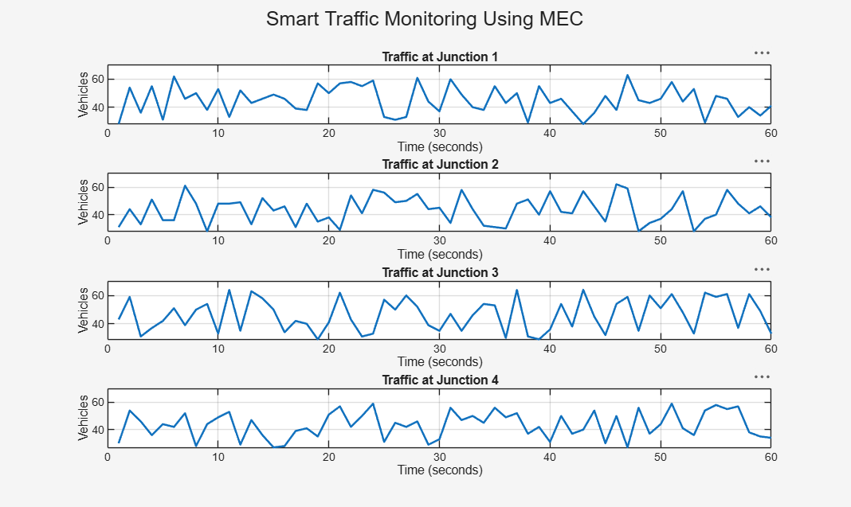

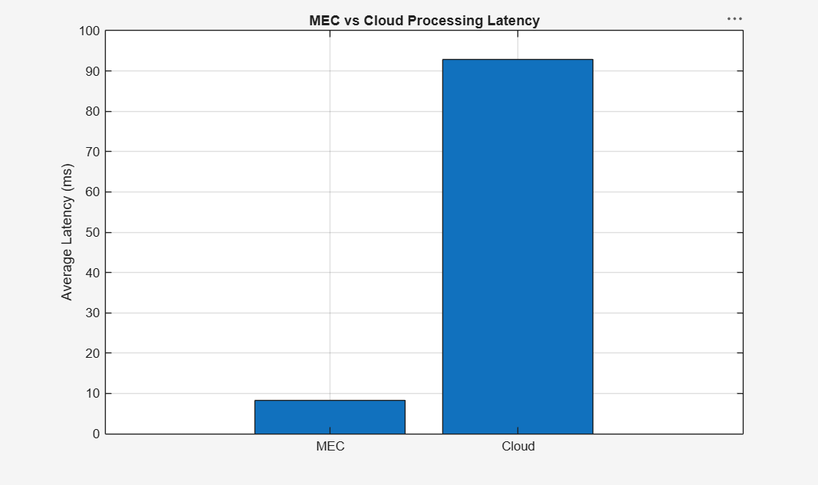
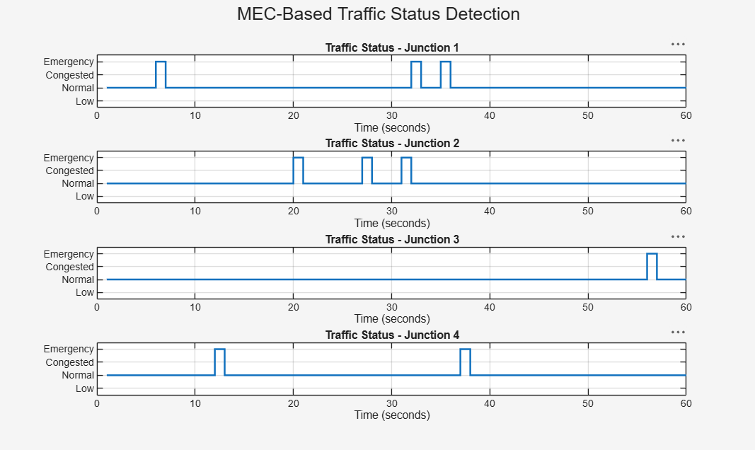

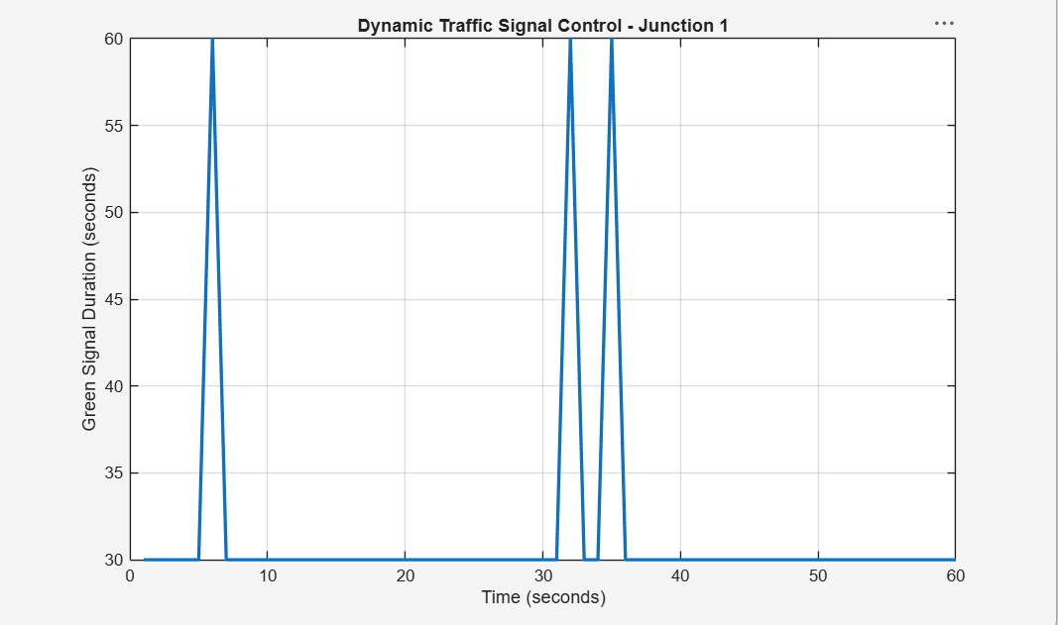
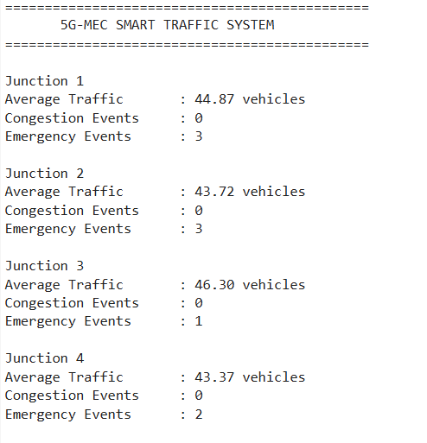
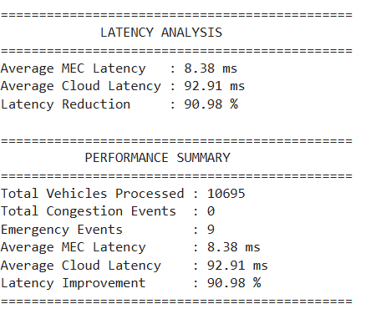

2.Design a 5G-enabled IoT framework for campus automation. (BL6)

Introduction
A smart campus contains many IoT devices for monitoring classrooms, energy, security, parking, and environmental conditions. 5G provides reliable and low-latency communication between these devices.
Aim
To design and simulate a 5G-enabled IoT framework for campus automation.
Objectives
- Monitor campus using IoT sensors.
- Use 5G for wireless communication.
- Automate classroom lighting and AC.
- Monitor energy consumption.
- Detect security events.
- Monitor parking and air quality.
- Compare edge and cloud latency.
Methodology
IoT Sensors → 5G Network → Edge Server
↓
Real-Time Automation
↓
Cloud Storage & Analysis
Result
The MATLAB simulation demonstrates smart lighting, AC control, energy monitoring, security alerts, parking monitoring, and latency comparison.
Conclusion
The proposed 5G-IoT framework improves automation, energy efficiency, security, and real-time monitoring, making it suitable for smart campus applications.

Code:
%% Q29 - 5G Enabled IoT Framework for Campus Automation
%
% This program simulates:
% 1. IoT sensors
% 2. 5G communication
% 3. Edge processing
% 4. Smart lighting
% 5. Energy monitoring
% 6. Security monitoring
% 7. Temperature monitoring
% 8. Smart parking
% 9. Cloud processing
% 10. MEC/Edge vs Cloud latency
%
% ---------------------------------------------------------

clear;
clc;
close all;

%% ---------------------------------------------------------
% 1. SYSTEM PARAMETERS
% ----------------------------------------------------------

simulationTime = 60;

time = 1:simulationTime;

numClassrooms = 5;
numParkingSpaces = 20;

%% ---------------------------------------------------------
% 2. INITIALIZE IoT SENSOR DATA
% ----------------------------------------------------------

temperature = zeros(numClassrooms, simulationTime);

occupancy = zeros(numClassrooms, simulationTime);

energyConsumption = zeros(numClassrooms, simulationTime);

motionDetection = zeros(1, simulationTime);

parkingAvailable = zeros(1, simulationTime);

airQuality = zeros(1, simulationTime);

%% ---------------------------------------------------------
% 3. GENERATE IoT DATA
% ----------------------------------------------------------

rng(20);

for c = 1:numClassrooms

for t = 1:simulationTime

% Temperature
temperature(c,t) = 22 + randn * 2;

% Classroom occupancy
if rand < 0.6

occupancy(c,t) = randi([10 40]);

else

occupancy(c,t) = 0;

end

% Energy consumption
if occupancy(c,t) > 0

energyConsumption(c,t) = ...
2 + rand * 3;

else

energyConsumption(c,t) = ...
0.5 + rand * 0.5;

end

end

end

%% ---------------------------------------------------------
% 4. SECURITY SENSOR
% ----------------------------------------------------------

for t = 1:simulationTime

% Random motion detection
if rand < 0.1

motionDetection(t) = 1;

else

motionDetection(t) = 0;

end

end

%% ---------------------------------------------------------
% 5. PARKING SENSOR
% ----------------------------------------------------------

for t = 1:simulationTime

occupiedSpaces = randi([5 numParkingSpaces]);

parkingAvailable(t) = ...
numParkingSpaces - occupiedSpaces;

end

%% ---------------------------------------------------------
% 6. AIR QUALITY SENSOR
% ----------------------------------------------------------

for t = 1:simulationTime

airQuality(t) = 40 + rand * 60;

end

%% ---------------------------------------------------------
% 7. 5G COMMUNICATION
% ----------------------------------------------------------

% 5G latency
fiveGLatency = 2 + rand(1,simulationTime) * 3;

% IoT sensing delay
sensorDelay = 1 + rand(1,simulationTime);

%% ---------------------------------------------------------
% 8. EDGE / MEC PROCESSING
% ----------------------------------------------------------

edgeProcessingDelay = ...
2 + rand(1,simulationTime) * 3;

% Cloud processing delay
cloudProcessingDelay = ...
25 + rand(1,simulationTime) * 15;

% Cloud network delay
cloudNetworkDelay = ...
40 + rand(1,simulationTime) * 30;

% Total edge latency
edgeLatency = fiveGLatency + ...
sensorDelay + ...
edgeProcessingDelay;

% Total cloud latency
cloudLatency = fiveGLatency + ...
sensorDelay + ...
cloudNetworkDelay + ...
cloudProcessingDelay;

%% ---------------------------------------------------------
% 9. SMART LIGHTING CONTROL
% ----------------------------------------------------------

% 1 = Light ON
% 0 = Light OFF

smartLights = zeros(numClassrooms, simulationTime);

for c = 1:numClassrooms

for t = 1:simulationTime

if occupancy(c,t) > 0

smartLights(c,t) = 1;

else

smartLights(c,t) = 0;

end

end

end

%% ---------------------------------------------------------
% 10. SMART AC CONTROL
% ----------------------------------------------------------

% 1 = AC ON
% 0 = AC OFF

smartAC = zeros(numClassrooms, simulationTime);

for c = 1:numClassrooms

for t = 1:simulationTime

if occupancy(c,t) > 0 && temperature(c,t) > 24

smartAC(c,t) = 1;

else

smartAC(c,t) = 0;

end

end

end

%% ---------------------------------------------------------
% 11. SECURITY MONITORING
% ----------------------------------------------------------

securityAlert = zeros(1,simulationTime);

for t = 1:simulationTime

if motionDetection(t) == 1

securityAlert(t) = 1;

else

securityAlert(t) = 0;

end

end

%% ---------------------------------------------------------
% 12. ENERGY SAVING CALCULATION
% ----------------------------------------------------------

normalEnergy = energyConsumption;

optimizedEnergy = zeros(numClassrooms, simulationTime);

for c = 1:numClassrooms

for t = 1:simulationTime

if occupancy(c,t) == 0

optimizedEnergy(c,t) = ...
energyConsumption(c,t) * 0.3;

else

optimizedEnergy(c,t) = ...
energyConsumption(c,t);

end

end

end

totalNormalEnergy = sum(normalEnergy(:));

totalOptimizedEnergy = sum(optimizedEnergy(:));

energySaved = ...
totalNormalEnergy - totalOptimizedEnergy;

energySavingPercentage = ...
(energySaved / totalNormalEnergy) * 100;

%% ---------------------------------------------------------
% 13. DISPLAY SYSTEM RESULTS
% ----------------------------------------------------------

fprintf('\n');
fprintf('==============================================\n');
fprintf(' 5G IoT SMART CAMPUS AUTOMATION\n');
fprintf('==============================================\n');

fprintf('\nNumber of Classrooms : %d\n', numClassrooms);

fprintf('Number of Parking Spaces : %d\n', ...
numParkingSpaces);

fprintf('\n--- Energy Analysis ---\n');

fprintf('Normal Energy Consumption : %.2f units\n', ...
totalNormalEnergy);

fprintf('Optimized Energy : %.2f units\n', ...
totalOptimizedEnergy);

fprintf('Energy Saved : %.2f units\n', ...
energySaved);

fprintf('Energy Saving : %.2f %%\n', ...
energySavingPercentage);

%% ---------------------------------------------------------
% 14. LATENCY ANALYSIS
% ----------------------------------------------------------

averageEdgeLatency = mean(edgeLatency);

averageCloudLatency = mean(cloudLatency);

latencyReduction = ...
((averageCloudLatency - averageEdgeLatency) ...
/ averageCloudLatency) * 100;

fprintf('\n--- Latency Analysis ---\n');

fprintf('Average Edge Latency : %.2f ms\n', ...
averageEdgeLatency);

fprintf('Average Cloud Latency : %.2f ms\n', ...
averageCloudLatency);

fprintf('Latency Reduction : %.2f %%\n', ...
latencyReduction);

%% ---------------------------------------------------------
% 15. SMART CLASSROOM OCCUPANCY GRAPH
% ----------------------------------------------------------

figure;

plot(time, occupancy(1,:), 'LineWidth', 1.5);

xlabel('Time (seconds)');
ylabel('Number of Students');

title('Smart Classroom Occupancy');

grid on;

%% ---------------------------------------------------------
% 16. TEMPERATURE GRAPH
% ----------------------------------------------------------

figure;

plot(time, temperature(1,:), 'LineWidth', 1.5);

hold on;

yline(24, '--', 'AC Threshold');

xlabel('Time (seconds)');
ylabel('Temperature (°C)');

title('Classroom Temperature Monitoring');

grid on;

%% ---------------------------------------------------------
% 17. ENERGY CONSUMPTION GRAPH
% ----------------------------------------------------------

figure;

normalEnergyTotal = sum(normalEnergy,1);

optimizedEnergyTotal = sum(optimizedEnergy,1);

plot(time, normalEnergyTotal, ...
'LineWidth', 1.5);

hold on;

plot(time, optimizedEnergyTotal, ...
'LineWidth', 1.5);

xlabel('Time (seconds)');

ylabel('Energy Consumption');

title('Energy Consumption Before and After IoT Automation');

legend('Normal System','IoT Automated System');

grid on;

%% ---------------------------------------------------------
% 18. SMART LIGHTING GRAPH
% ----------------------------------------------------------

figure;

stairs(time, smartLights(1,:), ...
'LineWidth', 1.5);

xlabel('Time (seconds)');

ylabel('Light Status');

yticks([0 1]);

yticklabels({'OFF','ON'});

title('Smart Lighting Control');

grid on;

%% ---------------------------------------------------------
% 19. SECURITY MONITORING GRAPH
% ----------------------------------------------------------

figure;

stem(time, securityAlert, ...
'LineWidth', 1.5);

xlabel('Time (seconds)');

ylabel('Security Alert');

yticks([0 1]);

yticklabels({'Normal','Alert'});

title('IoT Security Monitoring');

grid on;

%% ---------------------------------------------------------
% 20. PARKING AVAILABILITY
% ----------------------------------------------------------

figure;

plot(time, parkingAvailable, ...
'LineWidth', 1.5);

xlabel('Time (seconds)');

ylabel('Available Spaces');

title('Smart Parking Monitoring');

grid on;

%% ---------------------------------------------------------
% 21. AIR QUALITY MONITORING
% ----------------------------------------------------------

figure;

plot(time, airQuality, ...
'LineWidth', 1.5);

xlabel('Time (seconds)');

ylabel('Air Quality Index');

title('Campus Air Quality Monitoring');

grid on;

%% ---------------------------------------------------------
% 22. EDGE VS CLOUD LATENCY
% ----------------------------------------------------------

figure;

bar([averageEdgeLatency averageCloudLatency]);

set(gca, ...
'XTickLabel', {'Edge/MEC','Cloud'});

ylabel('Average Latency (ms)');

title('Edge Computing vs Cloud Computing Latency');

grid on;

%% ---------------------------------------------------------
% 23. PARKING STATUS DISPLAY
% ----------------------------------------------------------

fprintf('\n--- Parking Information ---\n');

fprintf('Average Available Parking Spaces : %.2f\n', ...
mean(parkingAvailable));

fprintf('Maximum Available Spaces : %d\n', ...
max(parkingAvailable));

fprintf('Minimum Available Spaces : %d\n', ...
min(parkingAvailable));

%% ---------------------------------------------------------
% 24. SECURITY INFORMATION
% ----------------------------------------------------------

totalSecurityAlerts = sum(securityAlert);

fprintf('\n--- Security Information ---\n');

fprintf('Total Security Alerts : %d\n', ...
totalSecurityAlerts);

%% ---------------------------------------------------------
% 25. FINAL PERFORMANCE SUMMARY
% ----------------------------------------------------------

fprintf('\n');
fprintf('==============================================\n');
fprintf(' FINAL PERFORMANCE SUMMARY\n');
fprintf('==============================================\n');

fprintf('Energy Saving : %.2f %%\n', ...
energySavingPercentage);

fprintf('Edge Average Latency : %.2f ms\n', ...
averageEdgeLatency);

fprintf('Cloud Average Latency : %.2f ms\n', ...
averageCloudLatency);

fprintf('Latency Improvement : %.2f %%\n', ...
latencyReduction);

fprintf('Security Alerts : %d\n', ...
totalSecurityAlerts);

fprintf('Average Parking Space : %.2f\n', ...
mean(parkingAvailable));

fprintf('==============================================\n');

%% ---------------------------------------------------------
% 26. COMPLETION MESSAGE
% ----------------------------------------------------------

disp(' ');
disp('5G IoT SMART CAMPUS SIMULATION COMPLETED.');
disp('IoT sensors generated campus data.');
disp('5G communication was simulated.');
disp('Edge processing performed real-time decisions.');
disp('Smart lighting and AC were automatically controlled.');
disp('Energy consumption was analyzed.');
disp('Security and parking were monitored.');
disp('Edge and cloud latency were compared.');

